Project Design Phase-II
Technology Stack (Architecture & Stack)

Date | 31 January 2025
Team ID | SWTID-2026-9795
Project Name | Streamlining IT Procurement: Automating Standard Laptop Orders with Flow Designer
Maximum Marks | 4 Marks

Technical Architecture:
The Deliverable shall include the architectural diagram as below and the information as per the table1 & table 2
Architecture: ServiceNow Standard Laptop Procurement Automation
Project Platform: ServiceNow Flow Designer and Service Catalog
Guidelines:
Include all the processes (As an application logic / Technology Block)
Provide infrastructural demarcation (Local / Cloud)
Indicate external interfaces (third party API’s etc.)
Indicate Data Storage components / services
Indicate interface to machine learning models (if applicable)
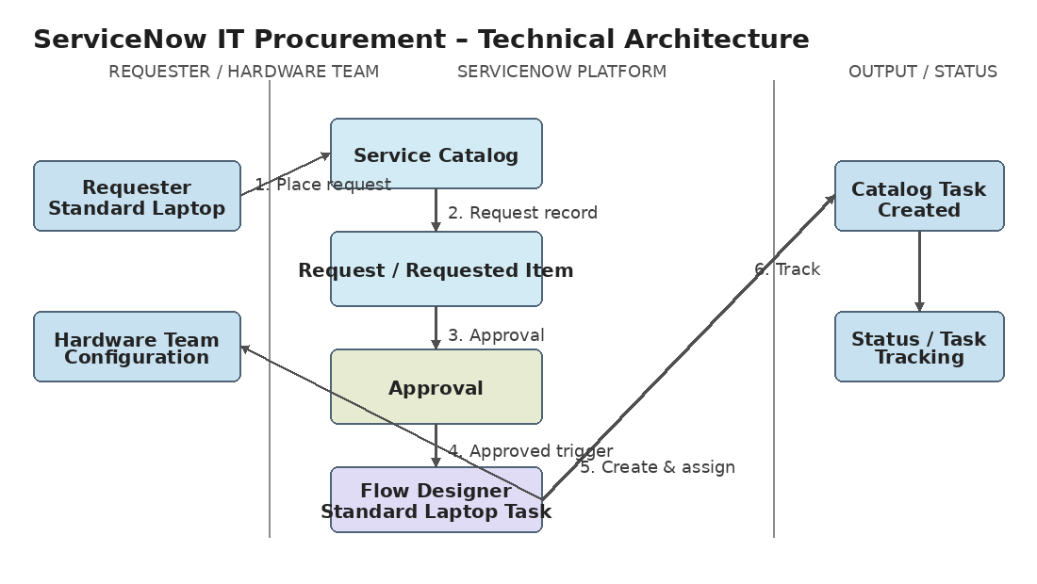

Table-1 : Components & Technologies:
S.No | Component | Description | Technology
 | User Interface | User interacts with the procurement request through ServiceNow Service Catalog. | ServiceNow Service Catalog
 | Application Logic-1 | Captures the approved service request and starts the automated task process. | ServiceNow Flow Designer
 | Application Logic-2 | Creates a Catalog Task for the requested Standard Laptop. | Flow Designer – Create Catalog Task action
 | Application Logic-3 | Updates task details and assigns the task to the Hardware group. | Flow Designer field values / Assignment group
 | Database | Stores request, Requested Item and Catalog Task records used by the workflow. | ServiceNow platform records
 | Cloud Database | Platform data used by the ServiceNow application. | ServiceNow platform data store
 | File Storage | No separate file-storage component is required by the project workflow. | Not applicable
 | External API-1 | No external API is used in the implemented Standard Laptop workflow. | Not applicable
 | External API-2 | No external API is used in the implemented Standard Laptop workflow. | Not applicable
 | Machine Learning Model | Machine learning is not part of this project implementation. | Not applicable
 | Infrastructure (Server / Cloud) | The application and workflow run on the ServiceNow platform. | ServiceNow platform / cloud service

Table-2: Application Characteristics:
S.No | Characteristics | Description | Technology
 | Open-Source Frameworks | No open-source framework is required for the implemented workflow. | Not applicable
 | Security Implementations | Approval and ServiceNow access controls are used; exact role/ACL configuration is not specified in the project. | ServiceNow access / approval controls
 | Scalable Architecture | Flow Designer provides a reusable automation pattern that can be assigned to the Standard Laptop catalog item. | ServiceNow Flow Designer
 | Availability | The procurement workflow is hosted within the ServiceNow platform and accessed through the Service Catalog. | ServiceNow platform
 | Performance | Automation removes manual task creation and assignment after approval, reducing processing delay. | Flow Designer automation

References:
ServiceNow Service Catalog – project implementation reference
ServiceNow Flow Designer – project implementation reference
Create Catalog Task action – project implementation reference
Standard Laptop catalog item – project implementation reference
Hardware assignment group – project implementation reference

